  
**Design Studio #4 - Weekly Progress Report #9**

DS Instructor: Gülbin DURAL

Partners:

* Fatih ÇALIŞ
* Fatih ÇAM
* Recep GÜNAY
* Huzeyfe HİNTOĞLU
* Sarah ILYAS

In the previous week, we were so excited because we made our demo with FPV camera setup and the RC transmitter in the weekly meeting. We placed the transmitter of the FPV camera at Z126 and its receiver at the end of the corridor upstairs next to the D135. The FPV set worked without a problem around 30-40 meters although there is a wall between them. There was no delay that can be observed with naked eye. We also tried the RC transmitter and we were able to control a servo motor using the transmitter with the same distance and conditions.

Since the budget is limited to 200$, we have decided to reduce the price for the FPV set, to improve the quality of the other components used in the robot. For that, Recep, Huzeyfe and I have conducted a research about the FPV cameras, receivers, transmitters and antennas. In most of the transmitter, the output is in the AV format, which requires an AV monitor. Thus, the available budget for the other component decreases if we use this kind of FPV receiver. However, there are some FPV receivers with Micro-USB output, which utilizes an Android smartphone as a display. We decided to give it a try and ordered it. After the receiver, we moved on to transmitter. Our transmitter had the output signal power of 2000mW, which is so powerful that we do not need. Therefore, to try different power options, we have ordered a transmitter whose output can be adjusted manually. Then, we ordered an FPV camera. Finally, we bought two different type of antennas for transmitter. The total list of the bought components with model names is as follow:

* Eachine ROTG02 Receiver
* Eachine TX801 Transmitter
* Caddx EOS2 FPV Camera
* Eachine VR D2 Antenna
* Eachine StingPad Antenna

After the communication subsystem, we moved on to the mechanical subsystem. We are planning to use a differential drive technique for the control of the robot. For that, we need a 2 Wheeled of 4 Wheeled chassis. We will identify the chassis after we decided on the shooting mechanism. There are different techniques to build a shooting mechanism that we found on Internet utilizing different mechanisms such as a pneumatic system, solenoid or spring. We decided to use the one with the spring due to its high force and less power. There are 2 alternatives for the shooting method with the springs.

The 1st alternative utilizes a spiral shaped mechanism. As the spiral rotates with the step or servo motor, the spring is compressed until the spiral completes full 360 degree rotation. When it completes its rotation, the spring is released and the force is created. This options is depicted in Figure1.

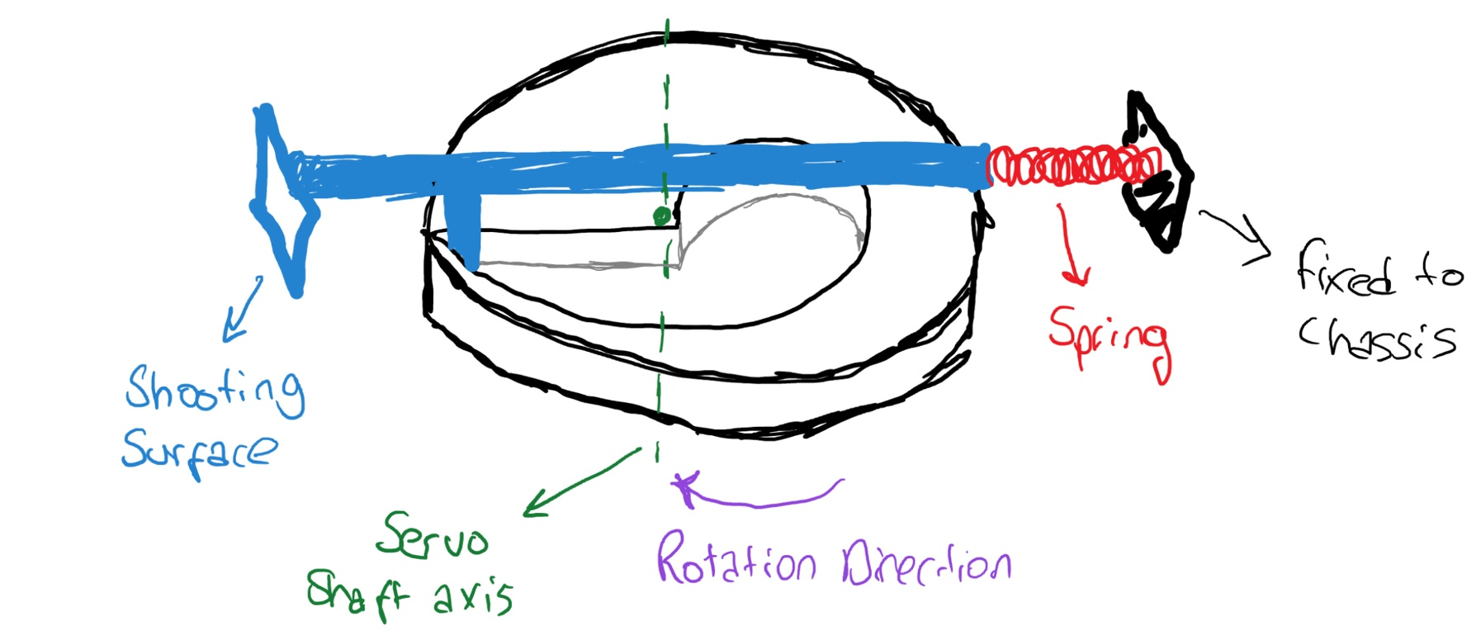

*Figure1: The spiral shaped shooting mechanism*

The 2nd alternative utilizes a rail which is free to slide in one axis and a gear with some broken cogs. In this case, a DC motor rotates the gear and slides the rail resulting in a compression in the spring. When the gear rotates until the broken cogs is aligned with the rail, it releases the rail and thus force is created. This option is depicted in Figure2.

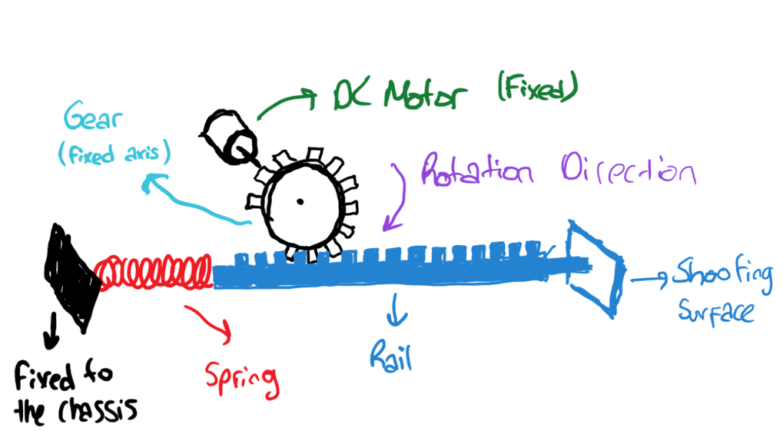

*Figure2: The shooting mechanism with rail and gear.*

We will decide on the shooting mechanism after some experiments and discussion later on. (Fatih ÇALIŞ)